令和６年度

第1回全校テスト

第３学年英語科

2024/06/27

Class：＿＿＿＿＿ No.：＿＿＿＿

Name：＿＿＿＿＿＿＿＿＿＿＿＿＿＿＿

１～４の問題はリスニングテストです。英文はすべて2回繰り返します。

１．（１）～（４）の英文の内容に合う絵を，それぞれのア～ウの中から１つずつ選び，その記号を書きなさい。
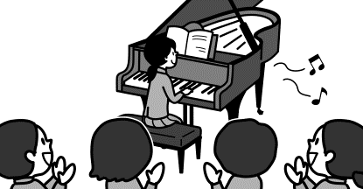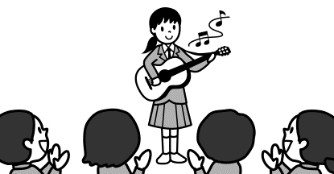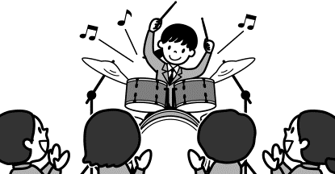（１）
ア
イ
ウ
Riko

Riko

Riko

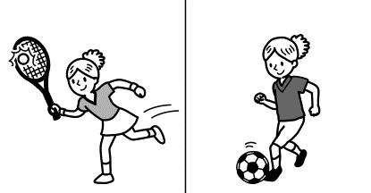
ウ
ア
イ
２年間
５年間
２年間
２年間
５年間
７年間
Sally

Sally

Sally
（２）

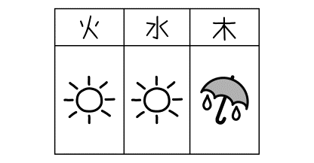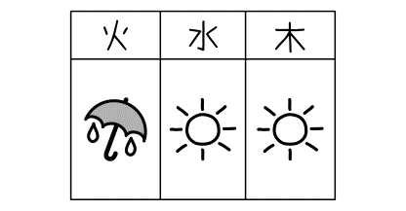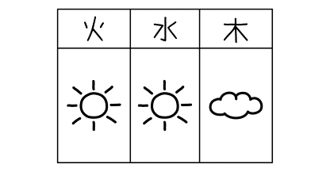
ア
イ
ウ
（３）

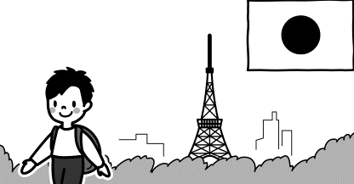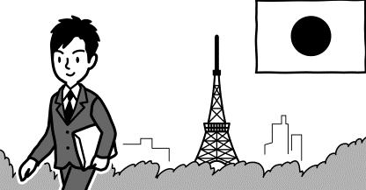
イ
ア
ウ
22年間

Kota
13年間

９年間

Kota
Kota

（４）

２．次の英語とその内容に関する質問を聞いて、その質問に対する答えを１つ選んで、記号で書きなさい。
(1)  ア In spring.  イ In summer.  ウ In fall.  エ In winter. | (2)  ア She studies English.  イ She cooks for her family.  ウ She cleans her room.  エ She learns cooking. | (3)  ア Yes, he did.  イ No, he didn’t.  ウ Yes, it was.  エ No, it wasn’t. | (4)  ア She worked at a hospital.  イ She helped her mother.  ウ She made her family happy.  エ She had lunch with her friends.

3．斉藤先生とジャックの対話の内容に合うように，（１）～（３）の（ ）内に適する数字を書きなさい。
メモ
（１）ジャックは（ ）年間，日本に住んでいる。
（２）ジャックは東京に（ ）年間住んだ後，名古屋に来た。
（３）ジャックは（ ）回，大阪に行ったことがある。

４．(1)(2)の英文の質問に対し，あなた自身の立場で答えなさい。【 】の条件にしたがって書きなさい。
(1) ___________________________________________________? 【４語以上の主語と動詞のある英文で】
(2) ___________________________________________________? 【５語以上の主語と動詞のある英文で】
リスニングテストは以上でおしまいです。答えは解答用紙に記入してください。
５．次の（ ）の中の語を適当な形に直しなさい。直す必要がない場合はそのまま書きなさい。
(1) Yuta enjoyed ( swim ) yesterday.
(2) I have ( be ) a big fan of Otani Shohei.
(3) About 7,000 different languages are ( speak ) in the world.
(4) I was ( sleep ) when your message came.
(5) It‘s not easy to (write ) haiku in English.
６．次の英文は，英字新聞の記事の要点をまとめた英文です。記事を読み取った時のメモをもとに英文の①～⑥に入る適切な英語を，１語または２語で書きなさい。ただし，文頭に来る語は，最初の文字を大文字にすること。
・千葉に特別な車いすを作る会社がある
・石井重行さん設立
・石井さんはオーダーメイドの車いすを設計
・一般的な車いすより軽くて，強くて，スポーティな車いすを作っている
・国枝さんや上地さんも使用
・世界に車いすが実用的でセンスの良くなることを示した
・従業員は選手の意見を注意深く聞く
・選手にとって最高の車いすを作るためにテクノロジーを使う

Technology Makes Sports Possible for Everyone
①_______________ a special wheelchair company in Chiba. The company’s wheelchairs ②___________ by Kunieda Shingo and Kamiji Yui. The wheelchairs are lighter, stronger, and sportier ③_____ ordinary types. The company ④___________ carefully to athletes’ ⑤_____________. It uses technology to make ⑥_______________ wheelchair for each athlete.

記事を読んだときにとったメモ

７．（ ）内の語を並びかえて、日本文にあう英文を書きなさい。問題の作成上小文字にしてある部分があるが、大文字にするべきところは大文字で書きなさい。
(1) Judy ( dinner / studies / always / after / math ). ジュディはいつも夕食後数学の勉強をします。
(2) ( you / subject / like / do / what )? あなたは何の教科が好きですか。
(3) Takaya ( fast / runs / as / Hiroki / as ). タカヤはヒロキとおなじくらい速く走ります。
(4) Bill ( his trip / that / was / us / told / fun ). ビルは私たちに旅行は楽しかったと話してくれた。
(5) ( the book / bought / have / you / yet )? あなたはもうその本を買いましたか。
８. (1)～(6)の英文を読んで,あとの問いに答えなさい。
(1) Japanese haiku について説明している英文は，ア，イのどちらですか。記号を書きなさい。
ア．First, they are written in sentences.  Second, the lines usually rhyme.  Third, we don’t have to include a seasonal word. | イ．First, they are not written in sentences.  Second, the lines do not have to rhyme.  Third, a seasonal word must be included.

(2) 次の英文は，秋田県のスキー場が，海外からの観光客のために企画した雪遊び活動（snow activities）をPRするために作ったホームページの一部です。英文の内容に合っているものを，下のア～エから一つ選び，その記号を書きなさい。
Let’s Enjoy Snow Activities
We have some snow activities in winter. First, you can walk on the snow *with snowshoes. Second, you can make a *snowman with your family and friends. Third, you can enjoy *snow rafting. It’s *safe and exciting. Many people come to Akita to enjoy these activities every year. Please come to Akita and have great experiences!
【注】*with snowshoes：かんじきを履いて *snowman：雪だるま *snow rafting：雪上ラフティング
*safe：安全な

ア People can enjoy some snow activities in summer.
イ People can make snowshoes to walk on the snow.
ウ Snow rafting is exciting, but it’s not safe.
エ Many people enjoy snow activities in Akita every year.

(3) 次の英文はバスガイドが，そのツアーの日程を説明している場面のものです。ツアーの日程を
簡単に表しているものを一つ選び，その記号を書きなさい。
Good morning, everyone. Today, we will visit some interesting places around Green City. First, we are going to Green City Museum. You can learn about local traditional festivals there. We will stay there for two hours. Please don't take pictures inside the museum. After leaving the museum, you will have lunch at a restaurant in Green Forest Market. After lunch, please enjoy shopping in the market. The market’s original jam is very popular. It is produced by local farmers. In the afternoon, we will visit Green Forest Castle. This old castle was built about 600 years ago. You can go inside the beautiful castle and go up its tower. The tower is 30 meters tall, and you can see beautiful views from the top. You can take pictures everywhere, so enjoy taking pictures, there. Now we will soon arrive at Green City Museum. Have a nice time.

ア グリーンフォレスト城 ➡ グリーンフォレスト市場 ➡ グリーン市立博物館
イ グリーン市立博物館 ➡ グリーンフォレスト市場 ➡ グリーンフォレスト城
ウ グリーン市立博物館 ➡ グリーンフォレスト城 ➡ グリーンフォレスト市場

(4) 次の英文は，ペルーにある世界遺産のマチュ・ピチュについて紹介しています。下線部の理由を日本語で具体的に説明しなさい。
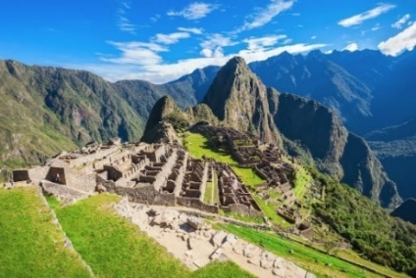
Machu Picchu
Machu Picchu is one of the famous world heritage sites. It’s a cultural heritage site because it was a part of *the Inca Empire. It’s also a natural heritage site. It was built on a mountain and the *scenery is wonderful. So this site is listed as a mixed heritage site.
【注】*the Inca Empire：インカ帝国 *scenery：景色

(5) 留学生のDavidが留学先の学校の紹介をしています。紹介文を読んで❶❷❸の質問に対し，主語と動詞のある英文で答えなさい。
Hello, I'm David. I'm interested in Japanese culture and I have been studying Japanese for two years. Today I will show you our school.
First, let's go to our gym. Our school has many different kinds of after school activities. One of them is the dance club. The dance club has thirty members. The members have been practicing for three hours because they have an important contest this weekend.
Next is our school library. Many students spend time at the library after school to study and finish their homework. I often talk with Ms. Hill here. She has been working as a volunteer at our school library since 1990. If you can, please tell me about your school, too. See you!

❶ How long has David been studying Japanese?
❷ How many members are there in the dance club?
❸ Why do many students spend time at the library after school?

(6) 新幹線の駅にいる外国人男性と駅員さんの対話です。①②の問いに日本語で答えなさい。
Man:  Staff: Man:  Staff:  Man:  Staff:  Man:  Staff: Man:  Staff: | Excuse me, I want to go to Hamada-cho. Where is the bus stop?  It’s in front of the *department store, but it may be difficult to take a bus today.  Oh, why?  Because it snowed a lot last night, some buses are not running, and others are late. Many people are now waiting to take a bus or a taxi.  Oh, no. What should I do?  How about taking the subway? You need to change trains twice to go to Hamada-cho, but I think that's the fastest way today.  That sounds like a good idea. I'll take the subway.  Do you know where to buy a subway ticket?  No, but I have this IC card. Can I use it to take the subway?  Yes, you can. 【注】department store デパート

①その外国人男性は，最終的に浜田町までどうやって行くことにしたのですか。
②交通手段を変更することになった一番の原因は何ですか。
９．(1)～(3)の場面の表現として適切な表現を下線部に書きなさい。※（ ）の中の内容になるように
(1) エマとひながゲームをしながら話している場面
Hina: You’re a good player. Do you usually play this game?
Emma : No, I don’t. ❶ I _______ ________ it with Gaku _______. (岳と一度だけやったことがある)
Hina ❷ Tom _______ ___________ __________ this game. （トムは一度も勝ったことがない）

(2) エマはひなの部屋にある写真を見て話している場面
Emma : This picture is very beautiful!
Hina : ❸ It ________ ___________ ____ Gaku. (岳が撮った写真)
❹ This lake _______ ___________ ____ many people . （たくさんの人が訪れる）

(3) レストランでメニューを頼んでいる場面
Customer: Excuse me. ❺ ____________ __________ ___________ _________ a menu?
Clerk : Sure. Here you are.
Customer: Thank you.

10．次の質問に対し，あなたの立場で理由を付け加えて答えなさい。英文の数は問わないが，15語～30語の英文で書きなさい。
Which country do you want to visit?
And why do you want to visit there?

解答用紙 Class: _______ No.: _______ Name: _________________________________________ Points: _________
1.  2点 | (1) | (2) |  | (3) |  | (4)
2.  2点 | (1) | (2) |  | (3) |  | (4)
3.  2点 | (1) |  | (2) |  | (3)
4.  2点 | (1) |  |  |  |  |  | 思考･判断  /26
 | (2)
5.  2点 | (1) |  | (2) |  | (3)
 | (4) |  | (5)
6.  2点 | (1) |  | (2) |  | (3)
 | (4) |  | (5) |  | (6)
7.  2点 | (1)  Judy .
(2)
?
(3)
Takaya .
 | (4)  Bill . |  |  |  |  |  | 知識･技能  /32
(5)
?
8.  3点 | (1) | (2) |  | (3)
 | (4)
 | (5)❶
 | (5)❷
 | (5)❸
思考･判断

/27
 | (6)① |  |  | (6)②
9.  2点 | ❶ I ________ _________ it with Gaku ________.
 | ❷ Tom _______ ___________ __________ this game.
 | ❸ It ________ ___________ ____ Gaku.
 | ❹ This lake _______ ___________ ____ many people .
 | ❺ ____________ __________ ___________ _________ a menu?
10.
5点
思考･表現

/15
リスニングテスト原稿
１～４の問題はリスニングテストです。英文はすべて2回繰り返します。

１．（１）～（４）の英文を聞いて，その内容に合う絵を，それぞれのア～ウの中から１つずつ選び，その記号を書きなさい。英文は，２回ずつくり返します。
（１）
ア
イ
ウ
Riko

Riko

Riko

（２）
ウ
ア
イ
２年間
５年間
２年間
２年間
５年間
７年間
Sally

Sally

Sally

（３）
ア
イ
ウ

（４）
イ
ア
ウ
22年間

Kota
13年間

９年間

Kota
Kota

（１）Riko played the drums at the school festival. She is liked by many students.
（２） Sally has played tennis for five years. She has also played soccer for two years.
（３） Today is Wednesday. It has been sunny since yesterday, but it will be rainy tomorrow.
（４） Kota is twenty-two years old. When he was a child, he lived in Canada for nine years. He has lived in Tokyo since he was nine years old.
解答：（１）イ （2）ア （3）ウ （4）イ

２．次の英語とその内容に関する質問を聞いて、その質問に対する答えを１つ選んで、記号で書きなさい。英語と質問は２回くりかえします。
(1)  ア In spring.  イ In summer.  ウ In fall.  エ In winter. | (2)  ア She studies English.  イ She cooks for her family.  ウ She cleans her room.  エ She learns cooking. | (3)  ア Yes, he did.  イ No, he didn’t.  ウ Yes, it was.  エ No, it wasn’t. | (4)  ア She worked at a hospital.  イ She helped her mother.  ウ She made her family happy.  エ She had lunch with her friends.

［放送台本］
① 比較（better, best）
I like fall. Fall is the best season for food. I like fish in fall. I like spring, too. The park near my house is famous for its cherry trees. Every spring many people come and enjoy eating and drinking under them.
Question: When do many people come to the park? （×２）

② 比較（as ～ as）
I like cooking. My parents are busy, so I often cook for my family after school. I can’t cook as well as my mother, but I feel happy when people say, “This is good,” and “Can I have more?”
Question: What does the girl often do after school? （×２）

③ 受け身形
F: What are you doing, Yuta?
M: I’m reading a book.
F: Oh, I know that one. It was written by Murakami Ryu, right?
M: No, it’s by Murakami Haruki.
F: Oh, I see.
Question: Was the book written by Murakami Ryu? （×２）

➃ SVOC
Last Sunday Yuki did some volunteer work in her city. In the morning she went to the city hospital. She helped sick people with their lunch. After lunch they said “Thank you” to Yuki. That made her happy.
Question: What did Yuki do last Sunday? （×２）

3．斉藤(さいとう)先生とジャックの対話を聞いて，その内容に合うように，次のメモの（１）～（３）のそれぞれの（ ）内に適する数字を書きなさい。
メモ
（１）ジャックは（ ）年間，日本に住んでいる。
（２）ジャックは東京(とうきょう)に（ ）年間住んだ後，名古屋(なごや)に来た。
（３）ジャックは（ ）回，大阪に行ったことがある。

Ms. Saito: Hello, Jack. I’m your homeroom teacher. Nice to meet you.
Jack: Hello, Ms. Saito. Nice to meet you, too.
Ms. Saito: Well, please tell me about you. How long have you lived in Japan?
Jack: For four years. I lived in Tokyo for three years, and I came to Nagoya last year.
Ms. Saito: I see. Have you ever visited any other places in Japan?
Jack: Well, I have visited Osaka two times. I have been reading books about Osaka since I first visited. It’s my favorite city.
Ms. Saito: Wow! Really?
Jack: Yes, I want to go there again.

解答：（１）４ （２）３ （３）２

４．(1)(2)の英文の質問に対し，あなた自身の立場で答えなさい。【 】の条件にしたがって書きなさい。
(1) How will the weather be tomorrow? 【４語以上の主語と動詞のある英文で】

(2) What makes you happy? 【５語以上の主語と動詞のある英文で】

リスニングテストは以上でおしまいです。答えは解答用紙に記入してください。

